**Clipper Research**

Prepared by Helen Martch

Friday, February 10, 2012

This document relates how I went about finding Product Clipper, what it says about how to use it, and a description of what happened when I actually used it.

**Contents:**

Finding Product Clipper page 1

The Product Clipper page page 3

Using Product Clipper page 5

**Finding Product Clipper**

* Googled “product clipper” and the 5th link on results was:

[**the Sears Buzz » Create Your Holiday Wish List with *Product Clipper***](http://www.google.com/url?sa=t&rct=j&q=product%20clipper&source=web&cd=5&ved=0CGAQFjAE&url=http%3A%2F%2Fthesearsbuzz.sears.com%2F2010%2F10%2Fcreate-your-holiday-wish-list-with-product-clipper%2F&ei=ZT81T8boO4jftgeQ27m1Ag&usg=AFQjCNF2bPkgQt-TsoF2Q6HcA5yBA1zTRA&cad=rja)

[*http://thesearsbuzz.sears.com/2010/10/create-your-holiday-wish-list-with-product-clipper/*](http://thesearsbuzz.sears.com/2010/10/create-your-holiday-wish-list-with-product-clipper/)

You +1'd this publicly. [Undo](http://www.google.com/search?q=Clipper&ie=utf-8&oe=utf-8&aq=t&rls=org.mozilla:en-US:official&client=firefox-a)

Oct 22, 2010 – Download the *Product Clipper* and you'll be adding products to your online wish list in no time. Best of all, the *Product Clipper* allows you to clip **…**

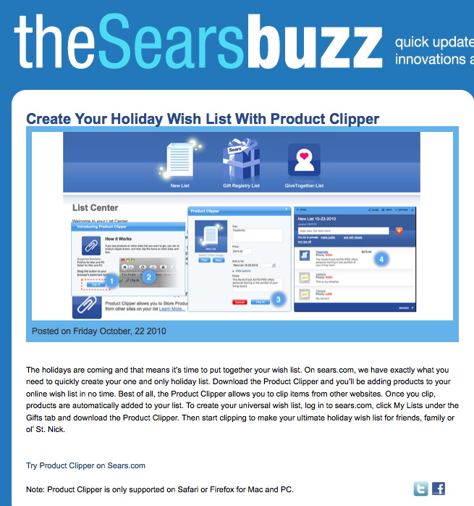

* Portion of the text on that page:

“…Download the Product Clipper and you’ll be adding products to your online wish list in no time. Best of all, the Product Clipper allows you to clip items from other websites. Once you clip, products are automatically added to your list. To create your universal wish list, log in to sears.com, click My Lists under the Gifts tab and download the Product Clipper….

[Try Product Clipper on Sears.com](http://www.sears.com/" \t "_blank)

Note: Product Clipper is only supported on Safari or Firefox for Mac and PC.”

* Went to sears.com, registered and logged in, looked at “Lists” in my profile but saw nothing re: Product Clipper
* Word docs in <http://dl.dropbox.com/u/95284/Clipper%202.zip> have logo that says “product clipper mygofer.com” so went to mygofer.com
* Clicked the “my lists” nav item at the far right of the blue nav bar on mygofer.com to get to <http://www.mygofer.com/shc/s/ShoppingListSortCmd?storeId=10175&catalogId=27151>which has a list of links on the right side under the heading “Tools”, “Product Clipper” is the first item in that list.

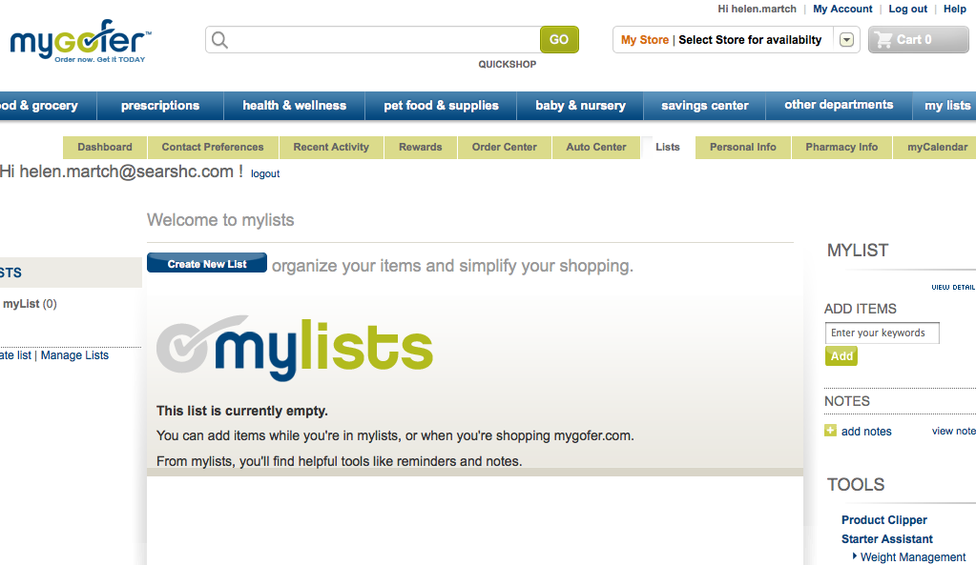

**The Product Clipper page**

* Clicking “Product Clipper” under Tools goes to the “product clipper from mygofer.com” page: <http://www.mygofer.com/shc/s/ManageListCenterToolsView?storeId=10175&catalogId=27151>

Despite the other pages having mentioned “downloading” product clipper, the instructions here don’t really have the user downloading anything. The instructions of what to do first are not called out very clearly but the first thing the user needs to do is grab a “Clip It” button from the page and drag it to their browser’s toolbar to add the plug-in to their browser. (Note: this page, as I see it in Firefox, does not give any statement regarding supported browsers like I’d seen in the SearsBuzz page.)

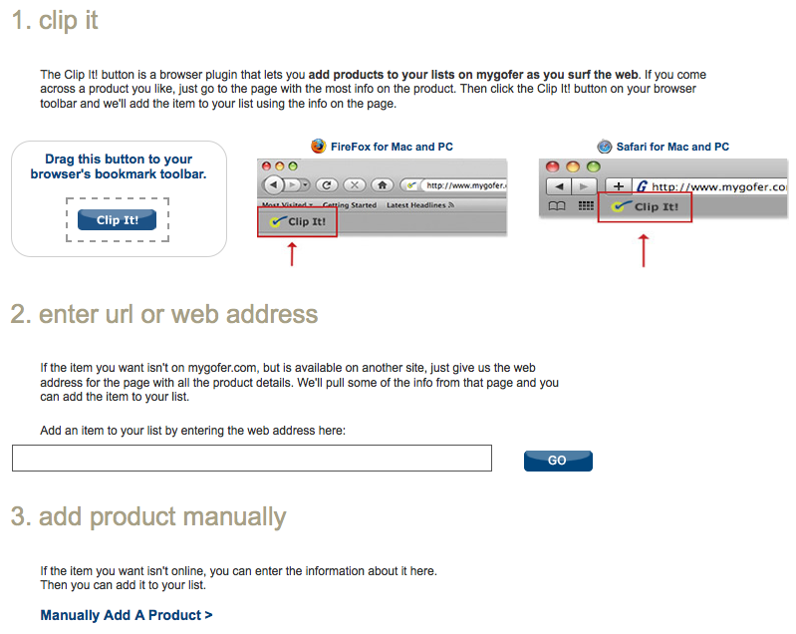

Once the plug-in has been installed, and the user has the “Clip It” button on their toolbar, then as the page says the plug-in “lets you **add products to your lists on mygofer as you surf the web**. If you come across a product you like, just go to the page with the most info on the product. Then click the Clip It! button on your browser toolbar and we'll add the item to your list using the info on the page.”

Also provided is a single field form on the page, in which the user can enter the product details URL for a product that they have found on the web that is not available on mygofer.com.

Lastly, there is a link to another page, <http://www.mygofer.com/shc/s/ManageListCenterToolsView?storeId=10175&catalogId=27151&manual=Y>, where the user can manually enter information for a product that is not on mygofer.com nor elsewhere on the web.

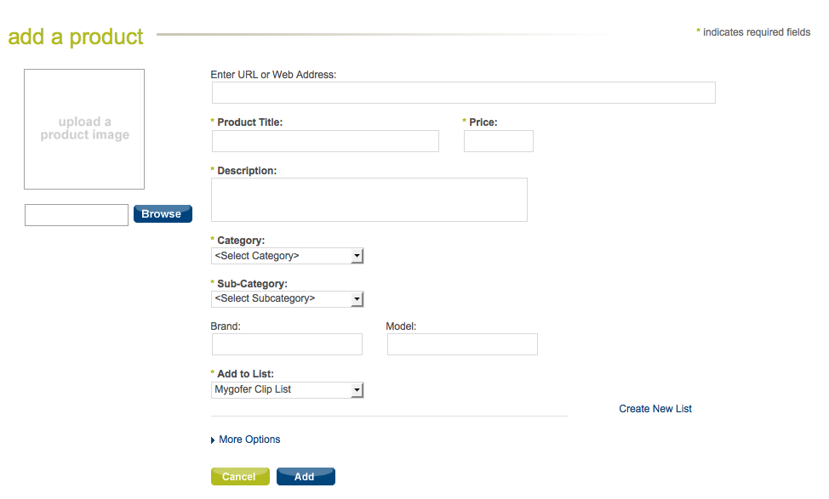

**Using “Product Clipper”**

* I went out into the web to find a product somewhere to “clip”. Clicking the “Clip It” button in my browser popped up this little window:

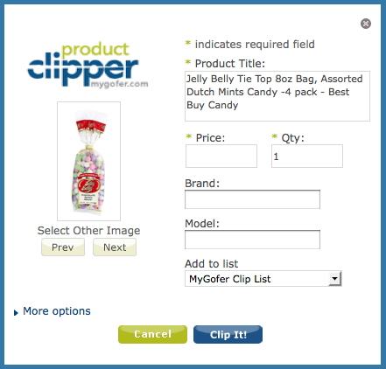

product clipper managed to pull in the Product Title and Quantity into required fields but not the price. Clicking the “Clip It!” button in the box, resulted in an error message being added to the top:

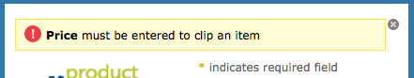

So, I added the price manually, not changing anything else, and clicked “Clip It!” again. The form slid up to hide the error message but nothing else occurred. So, I tried clicking “Clip It!” again and got a new error message:

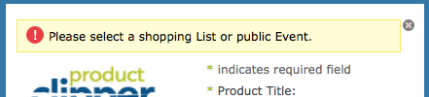

The options in the “Add to list” pulldown menu are:

* MyGofer Clip List
* myList
* Create New List

I selected “myList” and clicked “Clip It!” again. Briefly, I saw that the form was moving up to hide the error message but this time it continued beyond that to refresh the contents of the box to be the following:

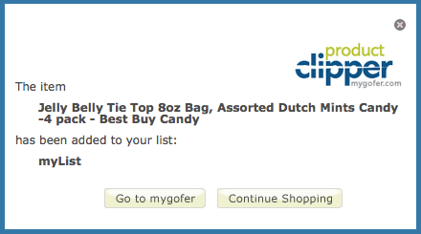

I clicked the “Go to mygofer” button. That opened another tab in my browser and went directly to the myGofer List Center (<http://www.mygofer.com/shc/s/ShoppingListSortCmd?storeId=10175&catalogId=27151&listId=21059158&listType=shoppingList>) with the product I had clipped listed.

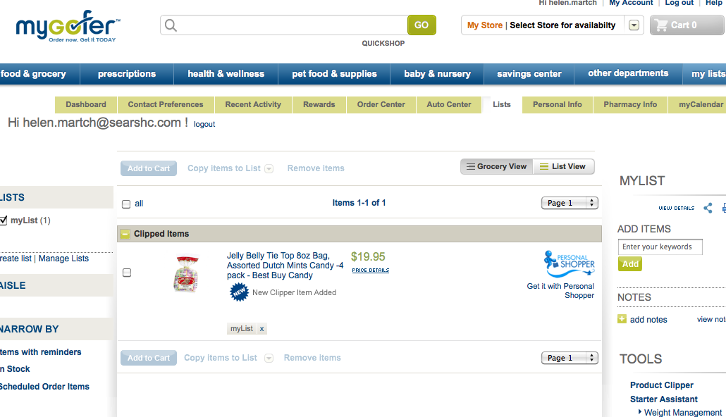

By default, the “Add to Cart” buttons on this page are grayed out but clicking the checkbox next to the item makes them available.

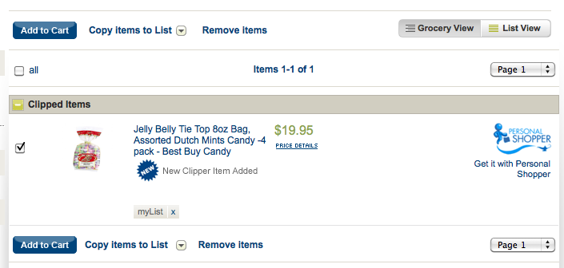

Presumably, from this point forward functionality is myGofer specific and not Product Clipper.

Since the page where I had been shopping was still open in the original tab, I returned to that to test the “Continue Shopping” button which is coded to call a javascript function MGClipper.closeClipper(); … as expected, it simply closes the popup overlay and stays on the same shopping page.